Obstacles Avoiding DIY Car
SHORT ASSEMBLY GUIDE
Follow the steps in order and check every connection before powering the car.
Step 1: Install the castor wheel  Attach the castor wheel to the wooden chassis. | 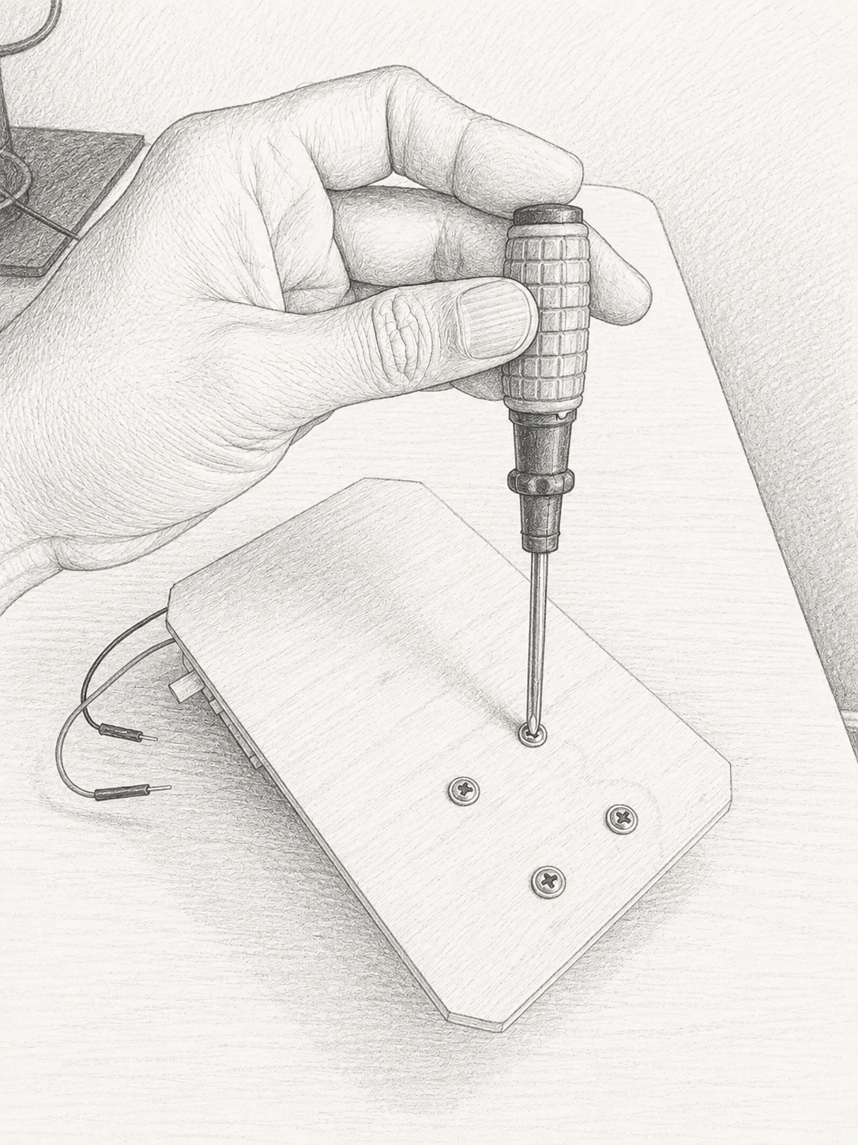  Castor wheel installation

Step 2: Install the front wheels
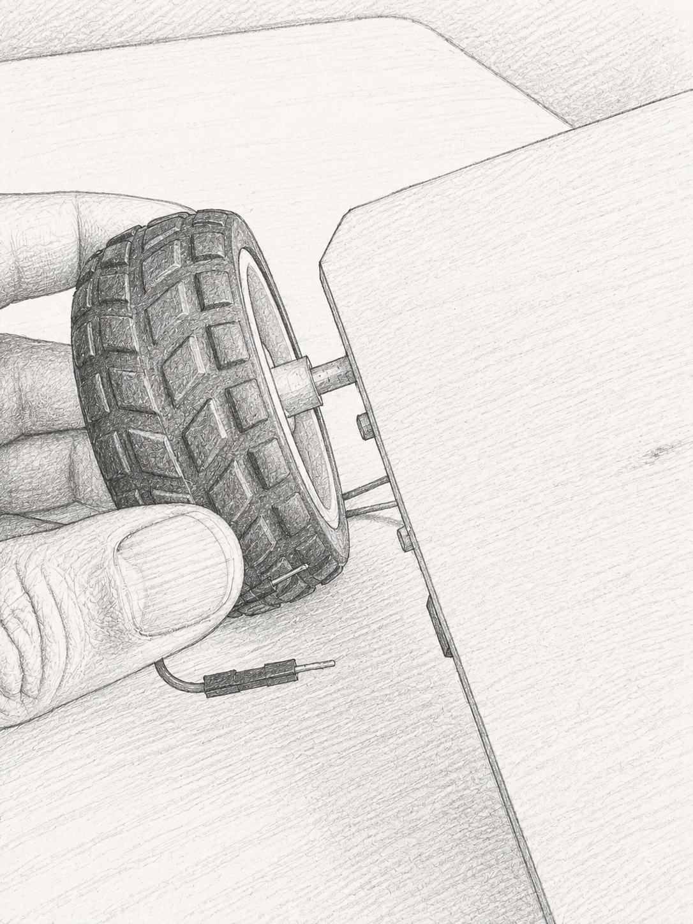  Front wheel position | 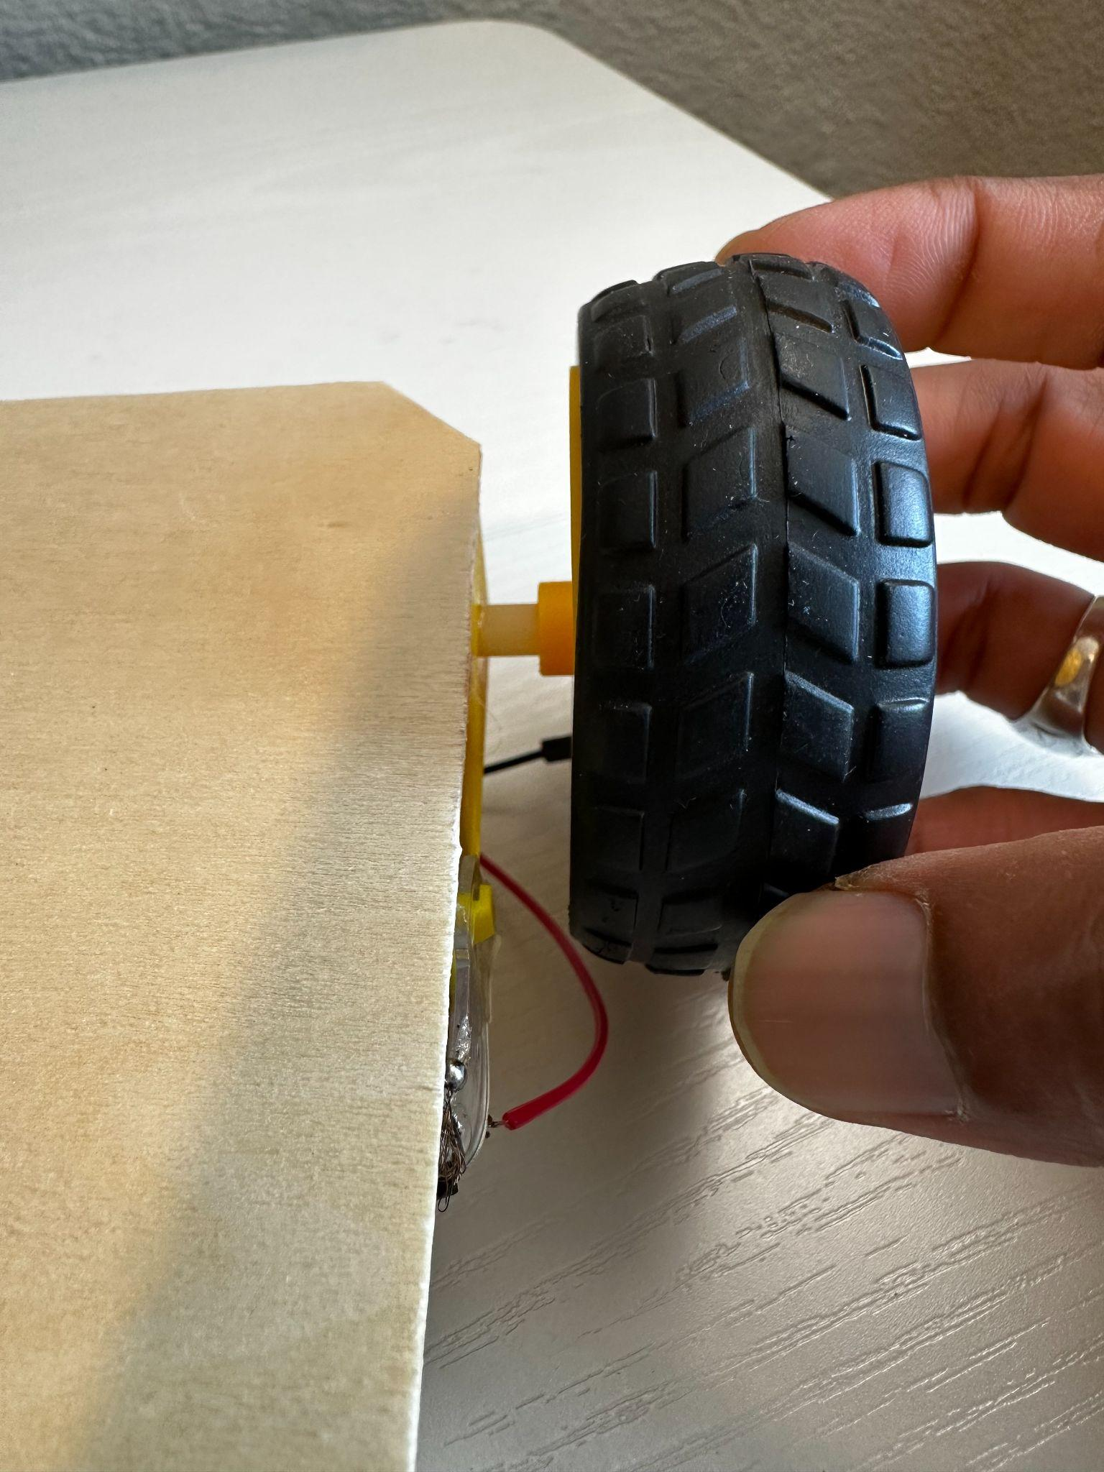  Front wheel attachment

Step 3: Mount the PCB  Secure the PCB to the wooden chassis. | 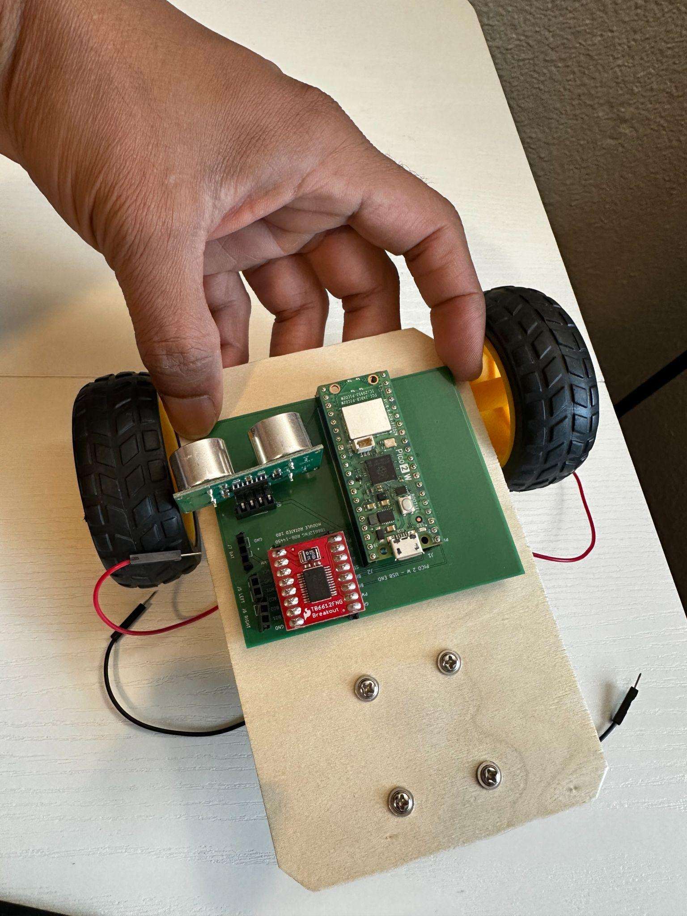  PCB mounted on the chassis

Step 4: Connect motor wires
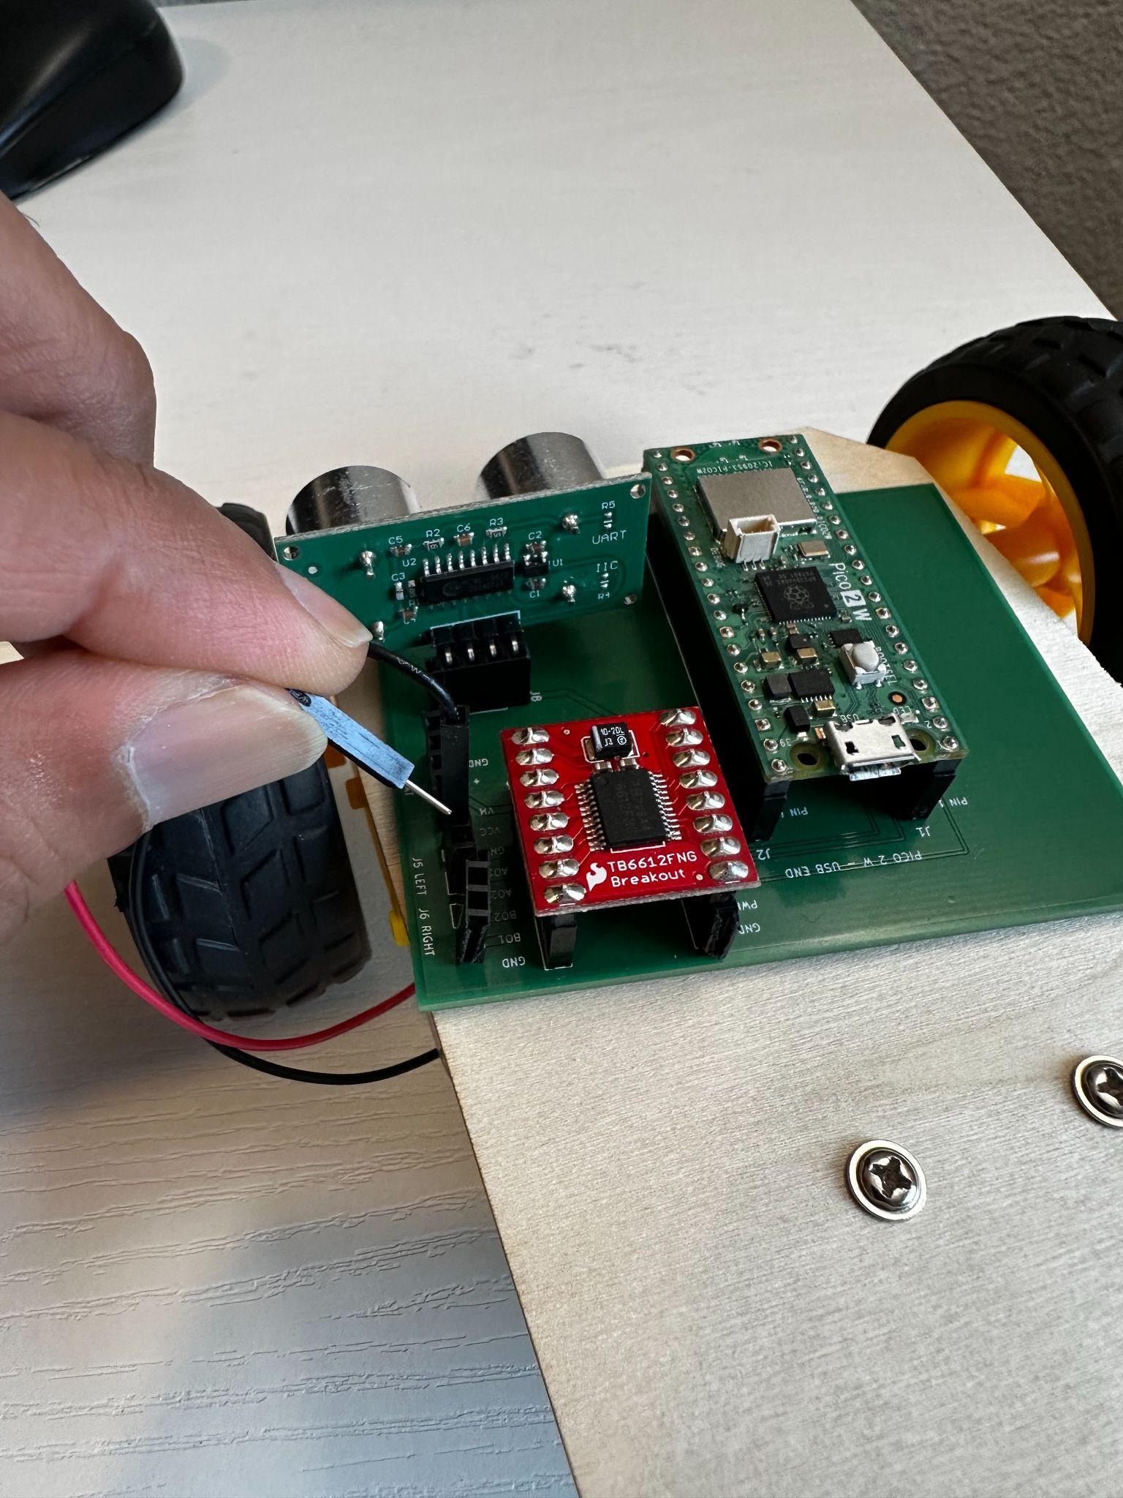  Left motor connection | 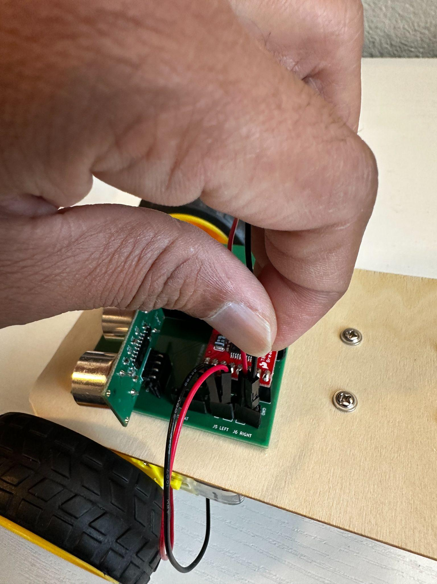  Right motor connection

Step 5: Connect batteries  Connect the batteries as shown. | 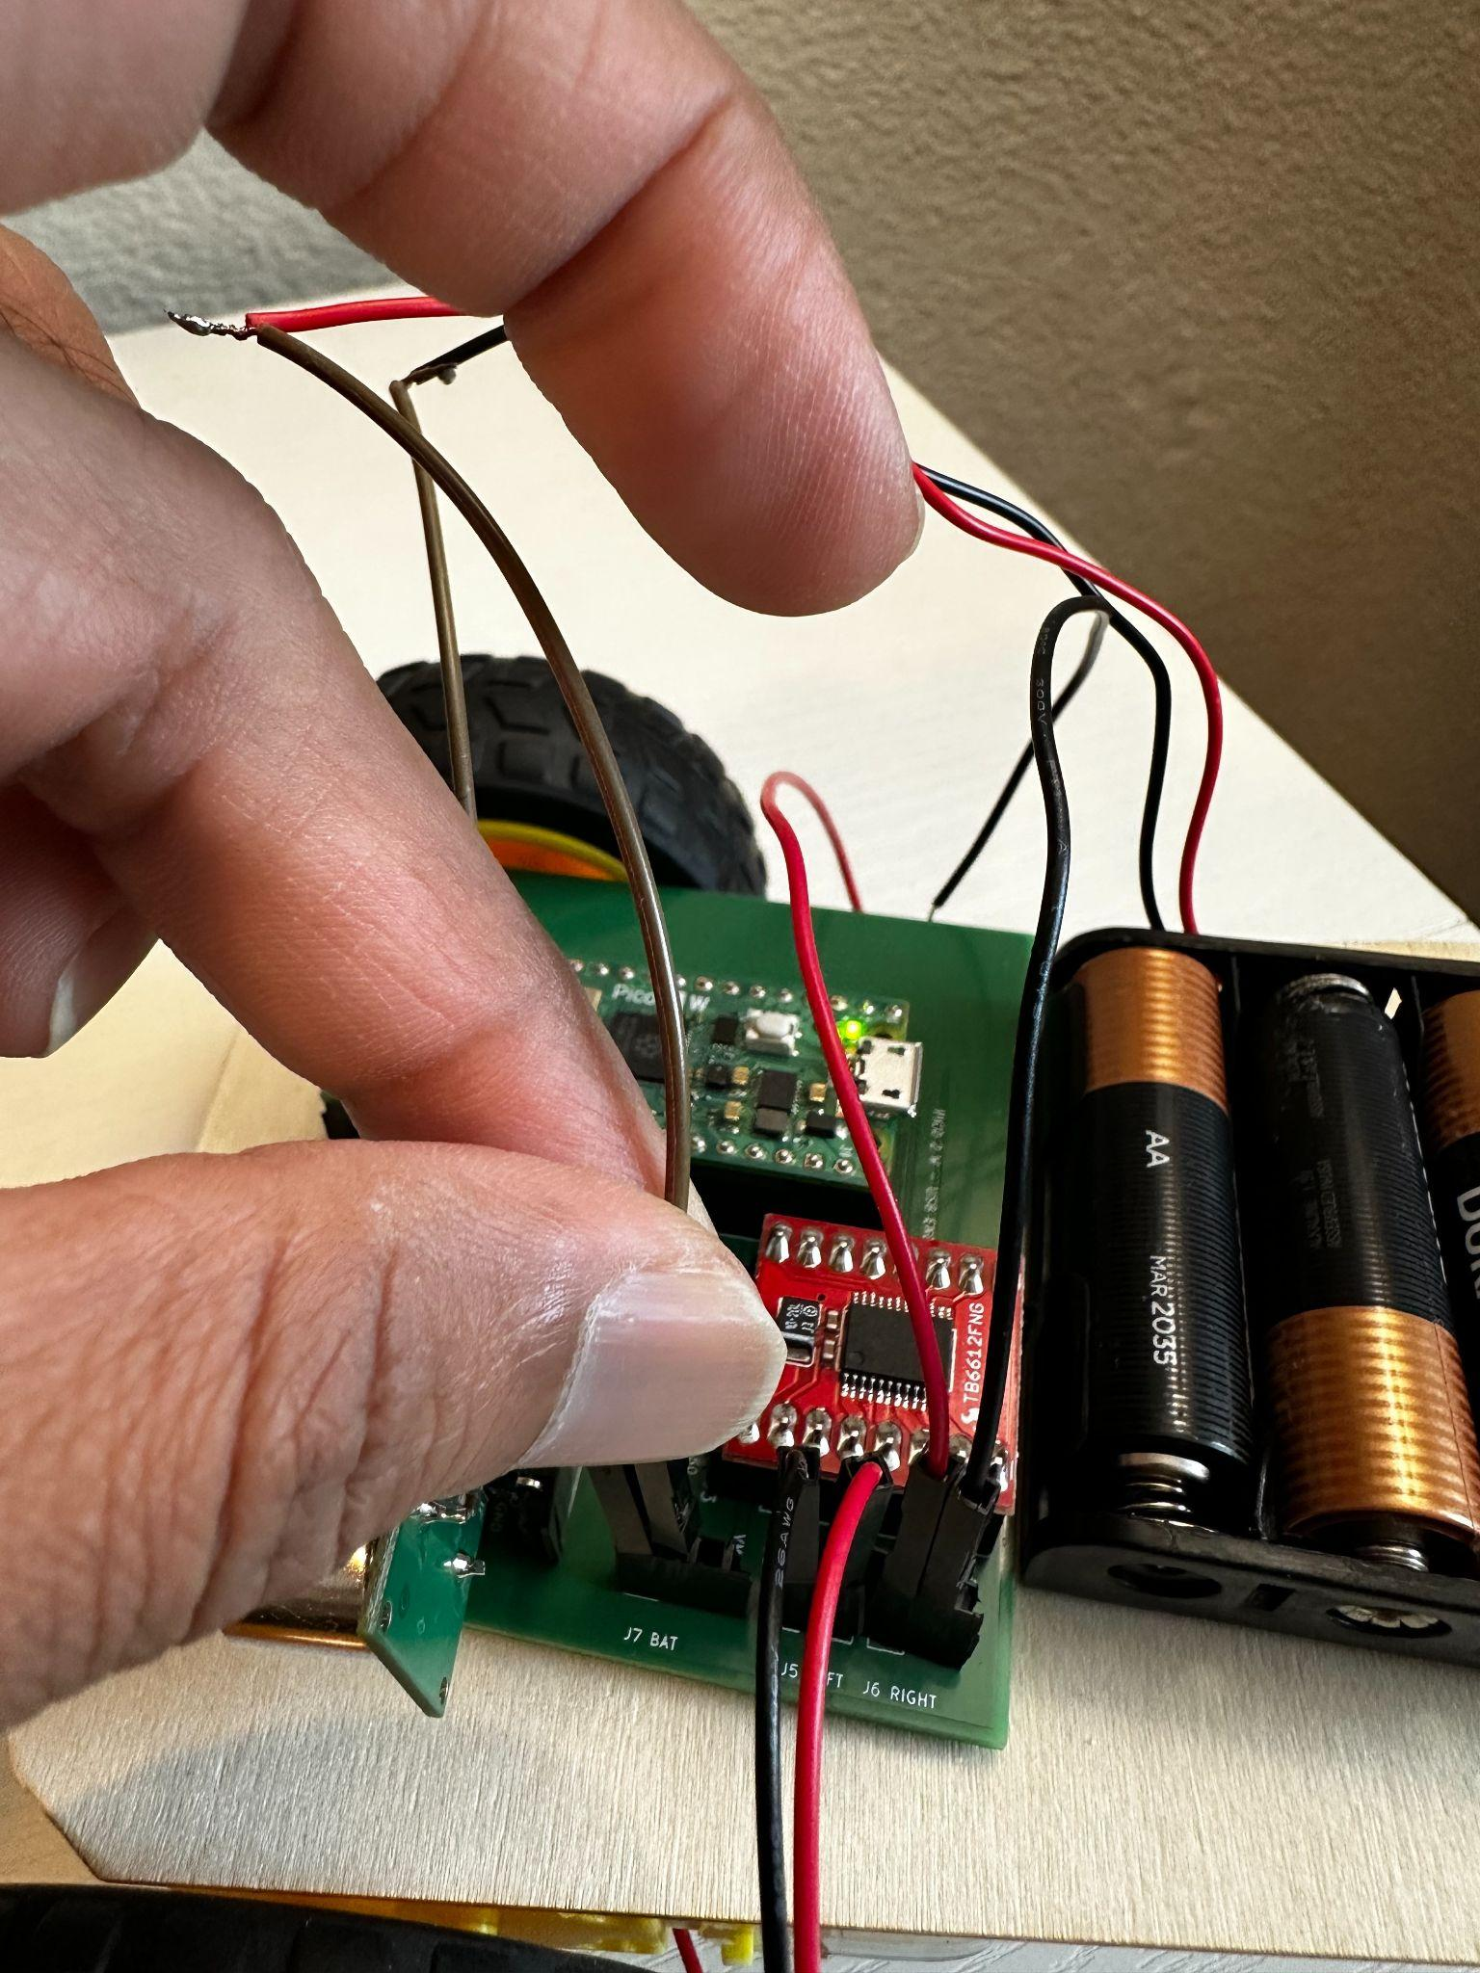  Battery connection

